Title Time New Roman 18 pt font size
First Author name¹∗ , Second Author name²
¹affiliation
Abstract
An abstract of 150 to 250 words that sketch the purpose of the study; basic procedures; main findings its novelty; discussions and the principal conclusions, should not contain any undefined abbreviations or references.(10 time new roman font size and style.
Keywords: 10 time new roman
Article history:
This article is open-access under the CC BY 4.0 license (http://creativecommons.org/licenses/by/4.0/).

1. Introduction
Describes briefly the background of the investigation with updated information and states the aim of the study The DC arc accidents are a the mein reason for potential fire hazard in solar systems. The photovoltaic power generation system is implemented with many connectors and cables, and the parts are used for a long period of operation of the power generation system have reduced insulation strength and loosened wiring due to aging by sunlight and damage caused by cause arcing accidents [1], [2] and [3].
In order to prevent damage along life and property from fire accidents, the photovoltaic power generation system must detect and extinguish the occurrence of DC arc accidents and must satisfy the operation safety guidelines [4].
For effective DC series arc fault detection, a detection method different from the AC power generation system is required. In the case of an AC power generation system, the arc can be detected from the instantaneous information of the voltage or current when the arc occurs because the energized voltage and current have a constant cycle. However, in the case of a DC power generation system such as photovoltaic power generation, it is difficult to instantaneously analyze the arc generation because the energized voltage and current. In this paper, we design a DC series arc accident detector based on the MATLAB using digital signal processor (DSP) and the results has compared and analyzed with the fast Fourier transform (FFT) and discrete wavelet transform (DWT). We propose the methods of frequency analysis to analyze the physically accident arc and implement the detection.
2. Materials and Methods
Provide sufficient details to enable the experiments to be reproduced. Support the techniques and methods used with references. Metric and standard international units should be used in this section and throughout the manuscript. Specify the computer software used for statistical analysis and define statistical terms, abbreviations, and symbols applied.
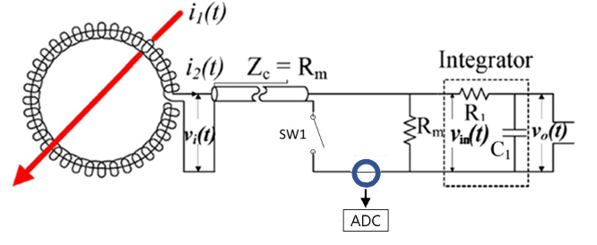
Fig. 1 Circuit of a photovoltaic DC series arc fault detection and block diagram of an arc fault detector

arc accident.
Results and Discussion
Present the results and their significance clearly. Graphs and tables should be self-explanatory. Do not repeat in figures or in the text the data presented in tables. Tables and figures should be numbered in the order of their mention in the text. Deals with critical review and interpretations of the results, and supported by relevant updated references. Repetition of data should be avoided. Results and Discussion should be combined It should end with brief conclusions
.$X\left(k\right)=\sum_{n=0}^{N-1}{x(n)e^{-j\frac{2π}{N} nk}} (1)$

Conclusion
This section should highlight the major, firm discoveries, and state what the added value of the main finding is, without literature references.
Conflict of interest
A conflict of interest statement must be placed at the manuscript as below: "The authors declare that there are no conflicts of interest regarding the publication of this manuscript".
References list must be provided according to the format of the (BAJEST) references in a consistent style. Where applicable, author(s) name(s). (Year of publication). Article title. Journal abbreviation. Volume (issue number): pagination.
References
- Mahmoud, M. I., Dessouky, M. I., Deyab, S., & Elfouly, F. H. (2007). Comparison between haar and daubechies wavelet transformions on FPGA technology. International Journal of Aerospace and Mechanical Engineering, 1(2), 141-145.
- Rapuano, S., & Harris, F. J. (2007). An introduction to FFT and time domain windows. IEEE instrumentation & measurement magazine, 10(6), 32-44.

∗ Corresponding author: Author Email

